User’s Manual

App Layout:

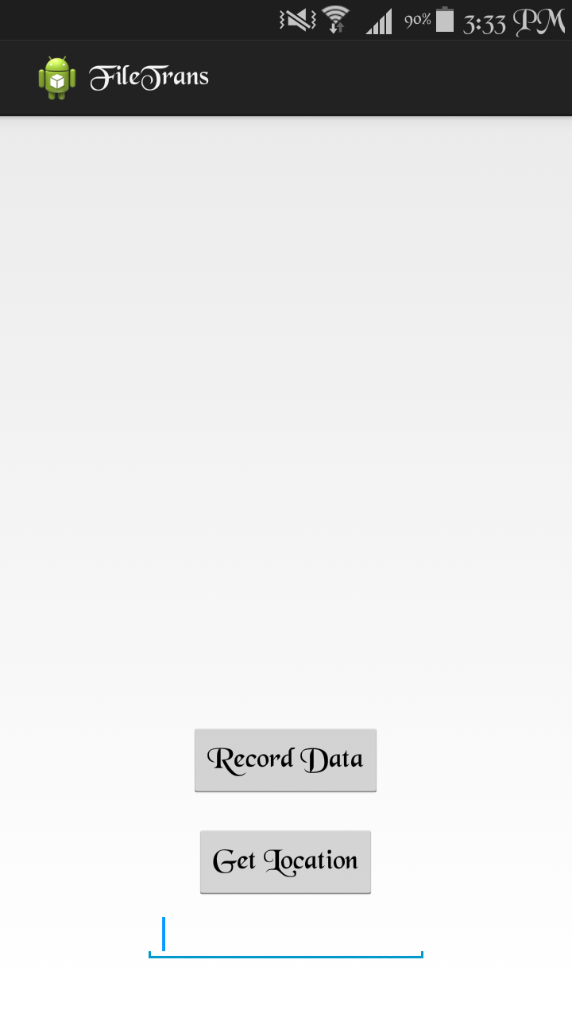

Location is shown here

1. Button to record the RSS data

2. Button to Send recorded data to the Server and get the location
IP Address and port number of Server

1. Record RSS Data

Make sure the Wi-Fi of the device is switched ON.

Click on Button 1 to record the RSS values received from the four specific routers (data is recorded for 30 seconds) with MAC Addresses:

- 00:26:3e:f5:9a:c2
- 00:26:3e:f5:9a:c0
- 00:26:3e:f5:9a:c4
- 4c:60:de:fc:2e:9c

2. Enter the IP Address and Port Number of the server

Enter the IP v4 Address of the computer where the server program is running and the port number, which the server program is listening to, separated by a colon, in the text box on the top right corner of the screen.

Format:
<IP Address>:<Port number>

3. Send Recorded data and get location

Click on Button 2 to send the recorded data to the server program that is running on the server. Make sure that the IP Address and port number of the server is entered correctly and the server program is running properly on the server side. The server program returns the user’s location which is displayed on the top left corner of the screen.

